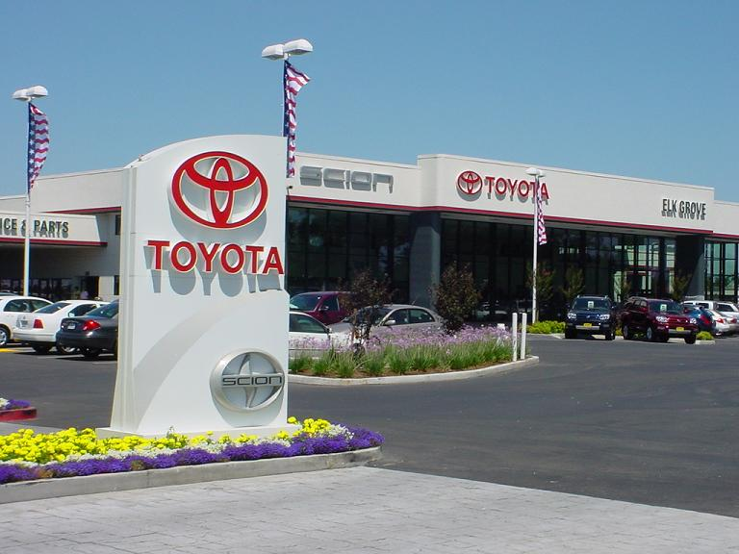

TOYOTA AUTOMOBILE COMPANY
BURNASTON A38/A50, DERYSHIRE
EAST MIDLANDS DE1 9TA UNITED KINGDOM
TEL: +448719153296
STAR PRIZE WINNER LONDON
Dear Lucky Winner,
This is to inform you that your Email have won you a prize of £500,000.00(Five Hundred Thousand Pounds) from the Yearly Toyota Lottery promotion United Kingdom which is organized by Toyota Company, “Your Email Address" were selected through a computer ballot system drawn from Nine hundred thousand email from Canada, United States, Asia, Europe, Middle East, Africa and Oceanic as part of our international promotions program which is conducted annually, we have only selected 20 people as our winners, through electronic ballot System without the winner applying.
MAKE SURE YOU SEND DETAILS TO THIS EMAIL TO AVIOD DISQUALIFICATION:
u.k1@live.co.uk
1 Name
2 Addresses
3 Countries / State
4. Mobile No
5. Sex
6. Age
7. Occupation.
8. Your Bank Name
9. Account Number
10: Email

PLEASE: YOU ARE TO FORWARD YOUR COMPLETE DETAILS INCLUDING BANK DETAILS TO US FOR EASY PAYMENT YOUR PASSPORT PHOTOGRAPH. (4X4}SEND YOUR INFORMATION TO TOYOYA AUTOMOBLE COMPANY EMAIL
u.k1@live.co.uk
Claims Manager,
DR COLLINS JONES
Tel +448719153296
EMAIL: u.k1@live.co.uk
