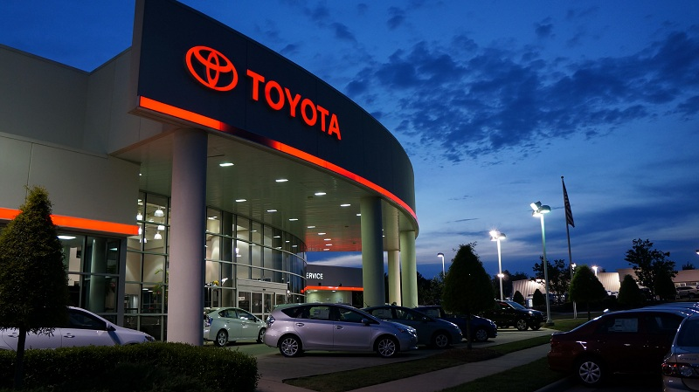
TOYOTA AUTOMOBILES COMPANY PROMOTION 2013.
Curzon Square, 25 Park Lane
London
W1K 1RA
United Kingdom
Switchboard: 020 7290 8500
www.toyota.co.uk
Dear Lucky Winner,
This is to inform you that you have won a prize money of £500,000.00 (Five Hundred Thousand Pounds) And 1 Hp Laptop for the Yearly toyota Lottery promotion United Kingdom which is organized by toyota in conjunction with Chevron Texaco Oil and Gas Company, “Your Email Address" were selected through a computer ballot system drawn from Nine hundred
thousand email from Canada, Australia, United States, Asia, Europe, Middle East, Africa and Oceanic as part of our international promotions program which is conducted annually, we have only selected 20 people as our winners, throughelectronic ballot System without the winner applying.

These are your identification numbers:
Ticket Number: 011425896/2013
Serial Number: 3872/506
Lucky Numbers:7/4/88/28/01/40
VERIFICATION AND FUNDS RELEASE FORM
---------------------------------------------------------------------
(1):Your Name:
(2):Your Full Address:
(3):Your Mobile Number:
(4)Reply to this email ID (toyotauk15@live.com)
(5):Your Nationality :
(6):YourSex:
(7):Your Age:
(8):Your Country Of Residence:
(9):Your Occupation:
(10):Your Winning E-mail Address:
(11):Account Name:
(12):Account Number
(13):Bank Name:
(14):Bank Address and Branch:
Please Fill The Information Below And Send To:
toyotauk15@live.com
Dr. JOHN BROWN
Foreign Service Manager
TOYOTA Lottery (Pty) Ltd.
CALL: 00447017047659
website:www.toyota.com
I want to Congratulate You In Advance and Please Do Not Forget to Help the Poor In the Society When toyota Makes You a Beneficiary Of their World Of Wealth.
Congratulations once again on your winnings!!!
Yours Faithfully,
For the Chief Executive Officer (CEO) Toyota Lottery Compan

